Task 3.2: Identifying key provisions and stakeholders of the Indian National Resource Efficiency Policy
Estimated time requirement: 55 minutes
Introduction
In 2019, the Indian government issued the Draft National Resource Efficiency Policy (NREP) to “create a facilitative and regulatory environment to mainstream resource efficiency across all sectors by fostering cross-sectoral collaborations, development of policy instruments, action plans and efficient implementation and monitoring frameworks.” (Draft National Resource Policy, p. i). In a first step, NREP addresses abiotic resources, specifically non-energy minerals. The policy aims to create a collaborative institutional structure to replace or consolidate the currently isolated interventions taking place in this field, and to strengthen and take forward the country’s resource efficiency agenda and sustainable development. This will require concerted efforts from different stakeholders. In this exercise, you will analyze the key provisions of the policy and identify the most important stakeholders, which will be responsible for implementation of the policy and their relationship between each other.

Table 1: Exercise structure
Part | Task | Time
1 | Form groups and analyze the summary of the Draft National Resource Efficiency Policy with respect to status, concerns and opportunities. Discuss the key provisions with your peers and capture your notes in table 2. | 20 min
2 | Based on the stakeholder mapping methodology presented in figure 1 below, please map out, classify and link those stakeholders, who need to be involved for the implementation of the policy. Please use the prepared flipchart for this exercise. | 35 min
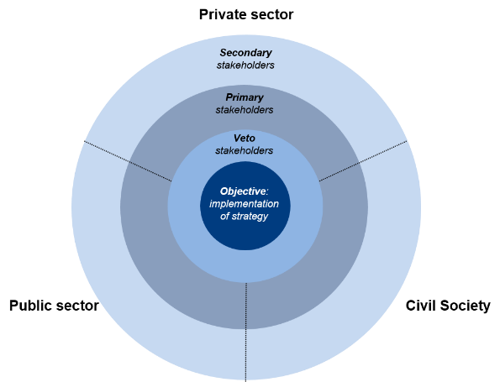
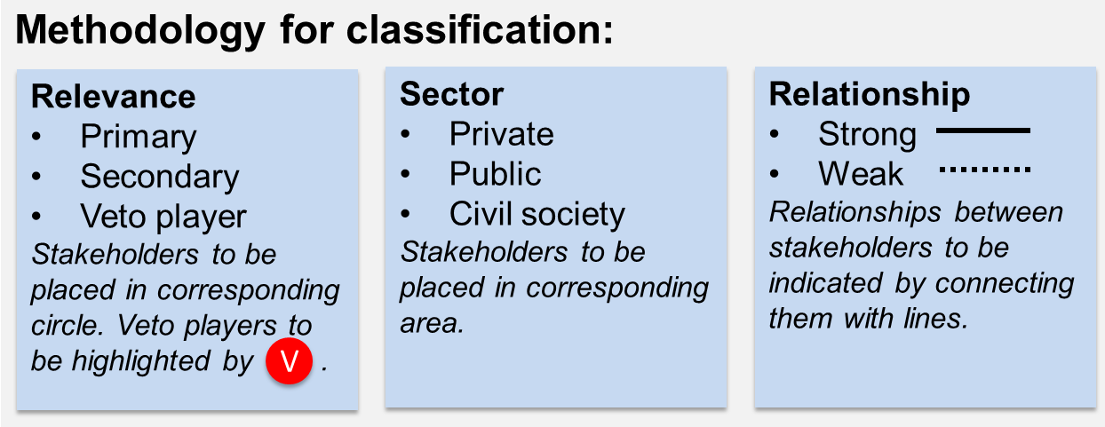
Figure 1: Stakeholder mapping methodology

Background information
Draft National Resource Efficiency Policy, India
India’s economy is marked by rapid economic growth with a GDP of 2.6 trillion USD. This economic growth has decreased poverty and promoted human development. However, it also came along with an augmented use of natural resources: India increased its material consumptions six times from 1970 to 2015 and is expected to double it again by 2030 in order to hold pace with population growth, increased urbanization and new aspirations of the growing middle and upper classes. The rising need for natural resource extraction has been accompanied by increased greenhouse gas emissions, land degradation, destruction of natural environment and loss of biodiversity as well as serious levels of resource depletion. Environmental degradation in turn has negative impacts on the economy, livelihoods as well as quality of life. Another compelling argument for CE and RE is the fact that many Indian industries depend on imports for many critical raw materials.
In the current policy landscape, there are multiple policies addressing the issue of resources, however, they are all isolated interventions and fail to capture the opportunities of resource efficiency across all stages of the life cycle. Most policies and interventions (e.g. eco-labelling, financial support for R&D, etc.) focus on energy efficiency or environmental issues, but do not yet directly address RE, circular business models or the use of secondary raw materials. Also, many policy interventions still focus on the end-of-life stage and end-of-pipe solutions. What is essentially missing is the integration of lifecycle thinking in an integrated and holistic manner to address the larger resource efficiency agenda. Collaborative institutional structures need to be formed and strengthened to take this agenda forward and to achieve the goals of NREP, such as:
- reduction in primary resource consumption to achieve the Sustainable Development Goals,
- creation of higher value with less material use through resource efficient and circular approaches,
- waste minimization,
- material security, and
- creation of green employment opportunities and business models.
A primary step in the implementation of the Policy and its goals is the creation of the National Resource Efficiency Authority (NREA) with the mandate to drive the agenda of resource efficiency across the country. NREA will be based on a collaborative structure with a core working group housed in MoEFCC, and a members group consisting of representatives from different ministries, state/union territory governments, government agencies and other stakeholders. An inter-ministerial National Resource Efficiency Advisory Board (NREAB) will provide necessary guidance on the aspects critical to the implementation of resource efficiency across all sectors.
It is crucial to have influence, participation and collective action of all major stakeholders including industry, policy makers, government agencies, academic, civil society organizations including non-profit institutions, think tanks and business groups, consumers, and technology developers to implement the policy in an integrative, comprehensive and effective manner.
National Resource Efficiency Policy, 2019 - Automotive Sector
The automotive sector, comprising of the automobile and auto component manufacturers, is one of the key sectors of the economy, having extensive forward and backward linkages. With more than 35 automobile manufacturing companies in the country, the industry contributes to more than 7% to India’s national income and accounts for 7-8% of India’s total employed population. However, growing use of internal combustion engine vehicles (ICEVs), increased road congestion and the consequent impact on tailpipe emissions, is increasingly posing threat to ambient air. This, indirectly, is creating opportunities for electric vehicles (EVs) on Indian roads. The government of India has demonstrated a strong commitment in introducing electric mobility in India and targets to increase the share of electric vehicles from its current level of less than 1% to nearly 30 % by 2030 while the share of electric buses is expected to reach as high as 100%. This implies that by 2030, the total number of electric two wheelers on Indian roads would be 211 million, and cars and buses will be around 34 million and 2.5 million respectively. Total material demand for ICEVs is expected to increase from 14 million tonnes to 100 million tonnes by 2030. EVs will also require many newer materials for enhanced performance over ICEVs, particularly for manufacturing batteries and powertrain. Since the volume of production of electric vehicles that run on lithium batteries is currently limited, the demand for related materials is currently insignificant. Consumption of materials by 2030 for EVs will increase significantly from its current level of 0.03 million tons to 11 million tons. Ferrous metals will contribute to 53% of the total estimated demand, followed by 17.4% of plastics and synthetics, 2.5% of aluminium and 7.2% of copper. Price volatility, dwindling domestic materials availability and sharp increases in imports of critical materials, calls for tapping opportunities in improving material consumption along their value chain through resource use, recovery and recycling.

Proposal for Action
A successful resource efficient automotive sector will need a very strong and financially viable end-of-life vehicle (ELV) management in India. Central Pollution Control Board has estimated that more than 8.7 million vehicles had reached the ELV status in 2015, and by 2025, the number of ELVs is estimated to reach over 21 million. Further, the recent ban on diesel vehicles by the National Green Tribunal implies that more vehicles will soon end up as ELVs. These vehicles usually end up reaching the un-organised dismantling centres. Auto components are either refurbished or sent for recycling. Efficiency of material recovery is very low due to inefficient dismantling. CPCB had issued guidelines to regulate the sector in an environmentally friendly manner, recommending a system of "shared responsibility" involving all stakeholders (government, manufacturers, dealers, insurers, consumers and recyclers). The guidelines also state that if large quantities of metal and other materials present in ELVs are salvaged or recycled, it can once again be used by various sectors, thus reducing the demand for virgin raw materials.

Needed Interventions
- Define ELV based in age, mileage and emission criterion
- Setting up of collection centres, which would collect vehicles from owners and carry out the deregistration process
- Setting up of de-pollution centres to remove hazardous materials from the vehicles. It will also be their responsibility to safely dispose the harmful materials
- Setting up of shredding centres which would segregate materials for recycling
- Introduction of recycling targets on dismantlers
- Careful separation at the de-pollution units and that could be sold to retailers or to used-part dealers with warranty
- Development of guidelines/Standard Operating Procedures (SOPs) by vehicle manufacturers to dismantle model and type of vehicle, which can prevent damage to components and encourage reuse of parts through proper channels and further label components for identification of materials for proper segregation and down-cycling National Resource iciency Policy, 2019 (Draft) vii
- Encourage material substitution and promote use of recycled materials in new ICEV and EV fleets

Targets
- 75% recycling rate for vehicles manufactured before 1990, 85% recycling rate for vehicles manufactured between 1990 and 2000, and 90% recycling rate for vehicles produced after 2000
- Establish 20 official dismantlers and equal number of PRO across major urban centres,
- by 2020
- Use of recycled materials in commercial vehicles and passenger vehicles to 25% of the kerb weight by 2030
More information: http://moef.gov.in/wp-content/uploads/2019/07/Draft-National-Resourc.pdf

Worksheet 1: Elements of National RE Policy
Table 2: Exercise template
Status
Concerns
Opportunities

Worksheet 2: Mapping key stakeholders
Please use the prepared flipchart to map out stakeholders and capture your results.
