Exercise 4a.1: Defining basic steps in a material flow analysis
Estimated time requirement: 10 minutes
Introduction
Material flow analysis (MFA) is a systematic assessment of the flows and stocks of materials within a system defined in space and time. Flows in a system are based on the law of conservation of matter, thus balancing all inputs and outputs or process over a given timeframe. Analysing a system makes all flows visible and helps identify the allocation, the interactions and the stock of resources. By conducting material flow cost accounting (MFCA), the costs of different materials, substance or goods in a system can be identified. This may uncover inefficiencies and savings potentials.
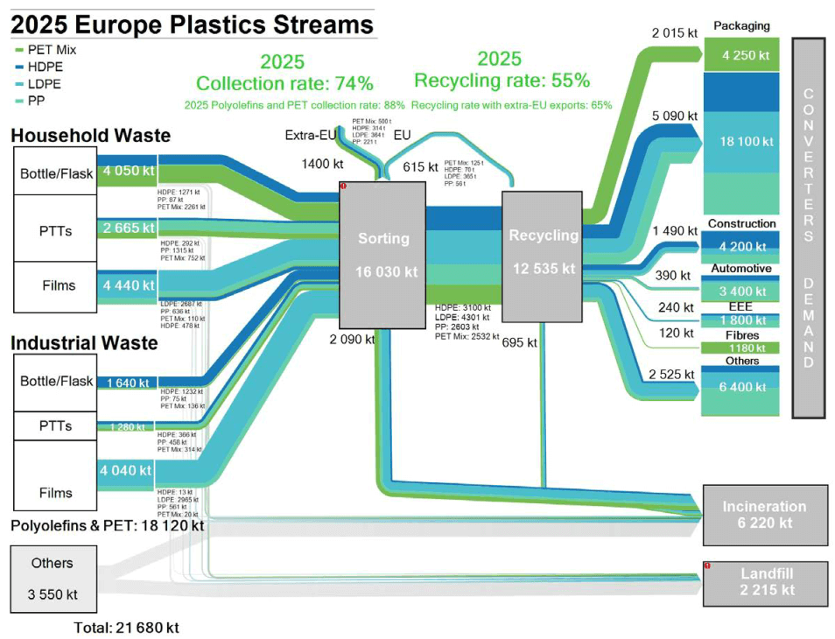
Figure 1: Example for an MFA on plastics streams in Europe in 2025
The application of MFCAs is guided by the standard „ISO 14051:2011 Environmental management — Material flow cost accounting — General framework“. Similar to the structure of LCAs, the standard suggests conducting an MFCA in four steps. In step 1, the overarching problem is defined, thus outlining the context and reason for conducting the exercise. In step 2, the system is defined. Step 3 comprises the definition of material stocks and flows, followed by interpretation and illustration (step 4). It should be highlighted that the steps are interlinked and can be revisited iteratively throughout the analysis, e.g. in order to adjust the overall system, redetermine goods/substance or redefining the problem. Details steps are displayed in the figure below.
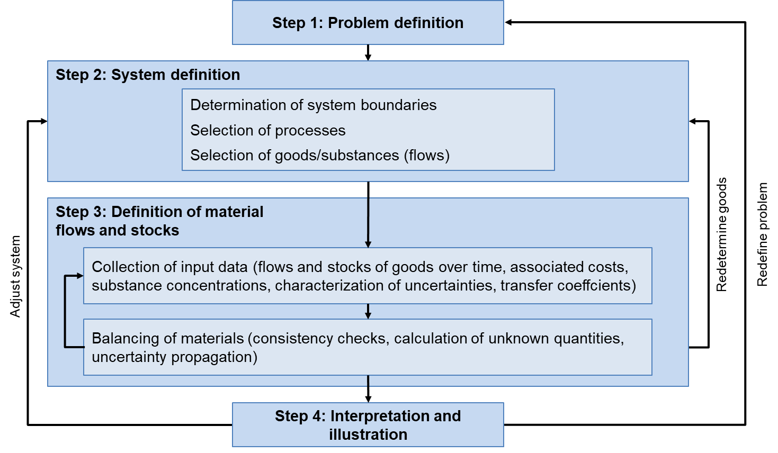
Figure 2: Steps and activities in a simplfied MF(C)A

Task
Please form groups of 2-3 people and examine the case study on Sainest Tubes, a manufacturer of carbon steel and seamless pipes. In June 2012, the Indian National Productivity Council followed and documented Sainest Tubes conducting an MFCA. Based on this case study, please define the activities in steps 1-4 by referring back to the MFA terminology presented (e.g. goods, flows, system boundaries). For this exercise, you should focus on the observation that “the abrasive cutting machine was running when not loaded” as well as the corresponding solution and savings as highlighted in table 1 (please ignore the investments). Results should be captured in the template below (figure 1).
Table 1: Case study Sainest Tubes
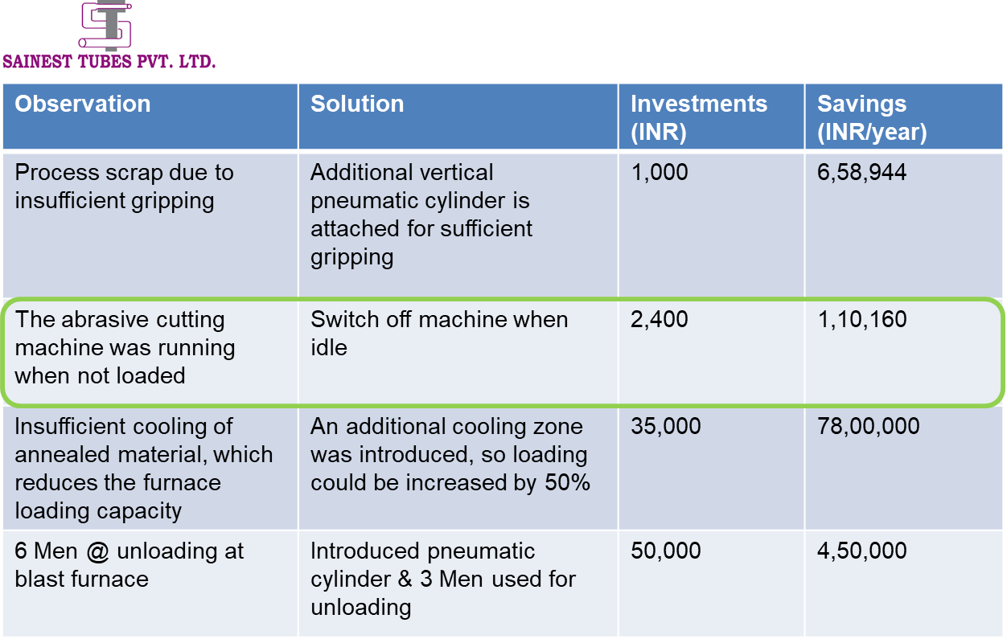

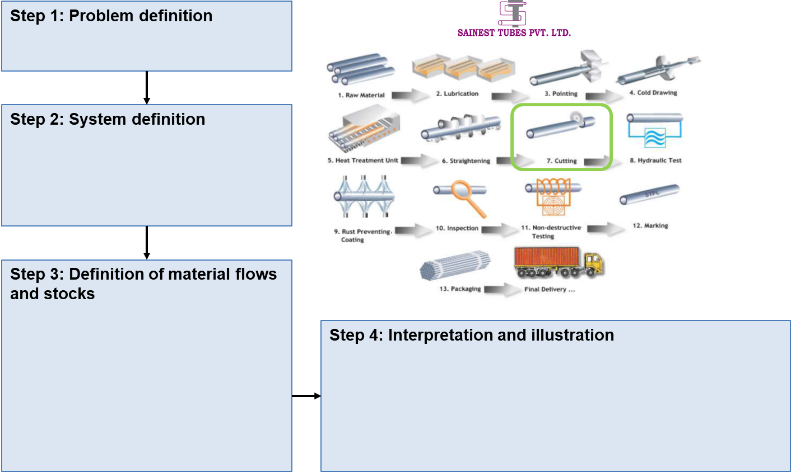
Figure 3: Exercise template

