Exercise 4a.3: Material Flow Analysis of a Coffee Machine
Estimated time requirement: 80 minutes
Introduction
This exercise about Material Flow Analysis (MFA) will provide you with a better understanding about the tool and its application. Upon completion of this exercise, you will be able to describe and illustrate simple techniques of analyzing and documenting material flow, identify sources of waste retrace waste and improvement potentials as well as select appropriate improvement measures, considering lifecycle implications. In addition, you will review and use different modes of visual presentations of MFA for further analysis and identification of improvement potentials.
Table 1: Structure of the exercise
Part | Tasks | Time
1 | Analyze the production process described in the case study  Quantify the process flows  Visualise your findings using a process flow or sankey diagram by populating the Charts A-D with data | 30 min
2 | Analyse the results; identify and compile at least three measures for improvement by populating table 4  Pitch the results to the “management board” (the group) by writing down your ideas on a flipchart and briefly presenting them (10 min preparation and 5 min presentation per group) | 30 min
3 | Reflect upon and re-assess the proposed improvement measures in terms of their lifecycle implications by populating table 4 | 20 min

Background information
Imagine that you have been engaged as a consulting team by a client who loves enjoying hot coffee in the morning, sometimes consuming several cups in course of the day. It is important to the client that the brewed coffee is of a consistent quality. The client wants your support in enhancing the efficiency in their coffee making process. As a first step, you are tasked to analyse and map out the material flows of the process, focusing on water and materials. Upon analysis, you will present your findings to the management board.
Description of process
First coffee is ground in the electrical coffee grinder (using about 400 Watts per hour). To grind one full load of coffee (about 90 g) it takes about 2 minutes. The ground coffee is then transferred to a coffee machine. A portion of left over coffee remains after grinding.
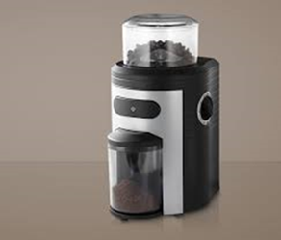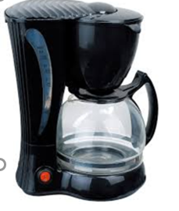
A single-time use paper filter is put into the percolator of the coffee machine and the ground coffee placed in the filter. Cold water is filled into the coffee maker. Once the machine is switched on, the water is pumped to a heating coil. The heated water runs through a small pipe on top of the percolator and drips onto the coffee in the filter paper. The coffee passes through the percolator and drips into the coffee pot beneath. After about 5 minutes, the process is complete.
The energy consumption is about 1000 Watt per hour. The coffee is ready for consumption and can be poured into the coffee cup. One pot of coffee is sufficient for about 2 cups of coffee. After the process the filter paper containing wet spent coffee powder is thrown into a dustbin and replaced with a new paper filter for the preparation of the next pot of coffee.
During the process, some of the water added to the machine evaporates from the open percolator. Not all coffee in the coffee pot is actually served, since the coffee cups used by the client differ in size. Around 10% remains in the pot, each time. Since this unserved coffee gets cold quickly, it is often poured away. Based on some measurements, you have collected following additional data:

Table 2: Data points
Data point | Weight
Coffee beans (used for grinding) | 90 grams
Water introduced into the coffee machine | 850 grams
Dry paper filter | 2 grams
Residues from grinding | 2 grams
Coffee made (with concentration of 1% coffee extract) | 800 grams
Residual water in coffee machine | 4 grams
Evaporated water | 13 grams
Coffee grounds (= wet filter and wet used coffee) | 123 grams
Further analysis of the coffee grounds shows that moisture content of paper filter after use is 50% of its dry mass; the moisture content of the wet used coffee is about 50%.
For the purpose of this exercise, the packaging of the coffee and the necessary energy for the process, as well as the waste heat produced are not taken into account. The same applies for the steps of filter production, coffee planting, roasting, storing and purchasing, water treatment, disposal of the filter and drinking.

Material flows and stocks
Table 3: Input and output data
Equipment
Balance period
Process steps
Input
- Coffee beans
- Water
- Dry filter
Input ∑
Product output
- Water
- Coffee extract
Product output ∑
Non-product output
Residual coffee powder (grinding)
Coffee grounds
- Filter
- Coffee
- Water
Residual water in coffee machine
Evaporated water
Non-product output ∑
Output ∑

Process flow
Template chart A: overview

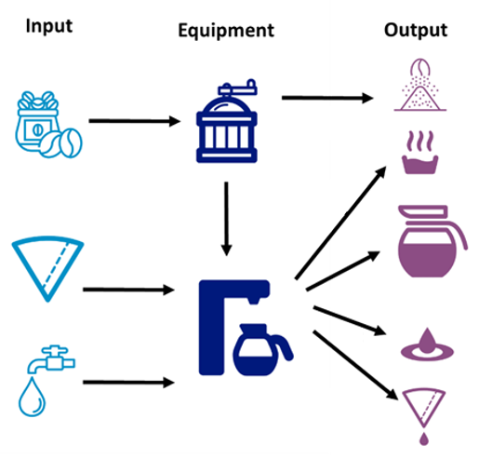
Template Chart B: overview
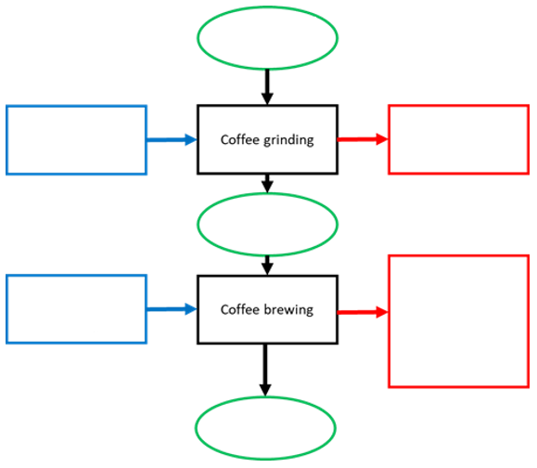

Process flow – Sankey diagram
Template chart C: Water efficiency
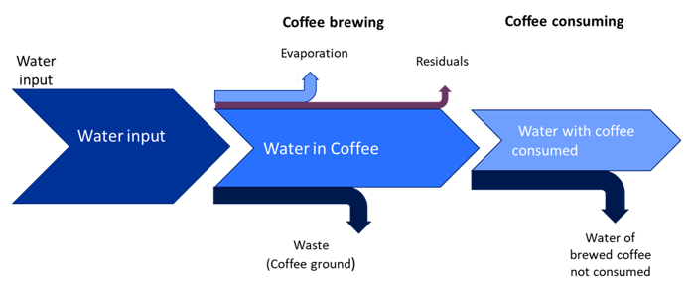

Process flow – Sankey diagram
Template chart D: Material efficiency (coffee)
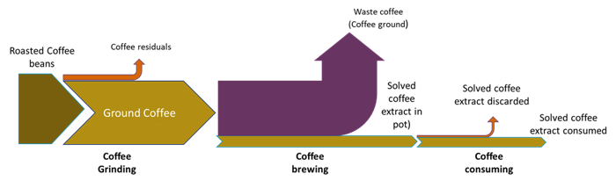

Measures for process optimization and impacts on lifecycle stages
Table 4: Exercise template
Measures for process optimization | Impacts on lifecycle stages
Good housekeeping

Technology modifications

Substitution of raw and process materials

Reduce, reuse, recycle

Product modifications

Other organisational measures

