Exercise 4d.1: Assigning macro-level resource use indicators
Estimated time requirement: 20 minutes
Introduction
Indicators are important instruments for monitoring and evaluating the progress made towards resource efficiency and circular economy. While indicators can be used at various levels (micro, meso, macro), many countries have started to define metrics for measuring resource use at the national level. Resource use indicators are essential to conducting Material Flow Analysis (MFAs), which typically distinguishes between 6 different kinds of metrics: total material requirement (TMR), total material input (TMI), direct material input (DMI), domestic material consumption (DMC), total domestic output (TDO) and total material output (TMO). For definitions, please have a look at table 1. When measuring a country’s GDP in relation to its DMC, we can derive an indication about the degree of resource productivity and economic decoupling. To account for the indicators various data sources can be used. Most material flows are statistically observed, while other, indirect flows associated to exports or imports must be estimated. After completing this exercise, you will be familiar with the terminology of resource use indicators and with possible data sources to determine material flows.
Structure of exercise
Part | Task | Time
1 | Please form groups of 2-3 people and examine the template on the next page. Based on the definition presented in table 1, please allocate the 6 macro-level indicators (TMO, TMI, DMC, TDO, DMI, TMR) to the slots 1-5 in figure 1 on worksheet 1. | 10 min
2 | Material inputs and output can be accounted for by using various data sets. Examples are listed on worksheet 2. Allocate the examples of data sets to each category: i) material inputs and ii) material outputs. Add two additional data sets to each category respectively. | 10 min
Background information
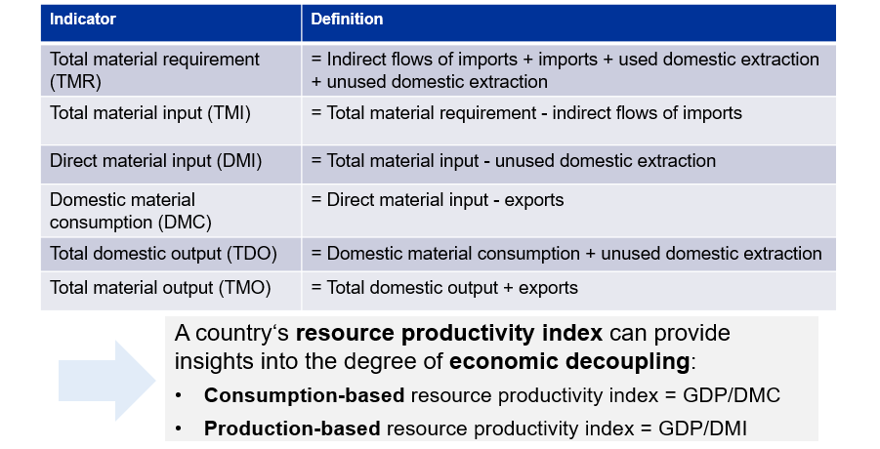
Figure 1: Definitions of resource use indicators applied in MFAs

Worksheet 1
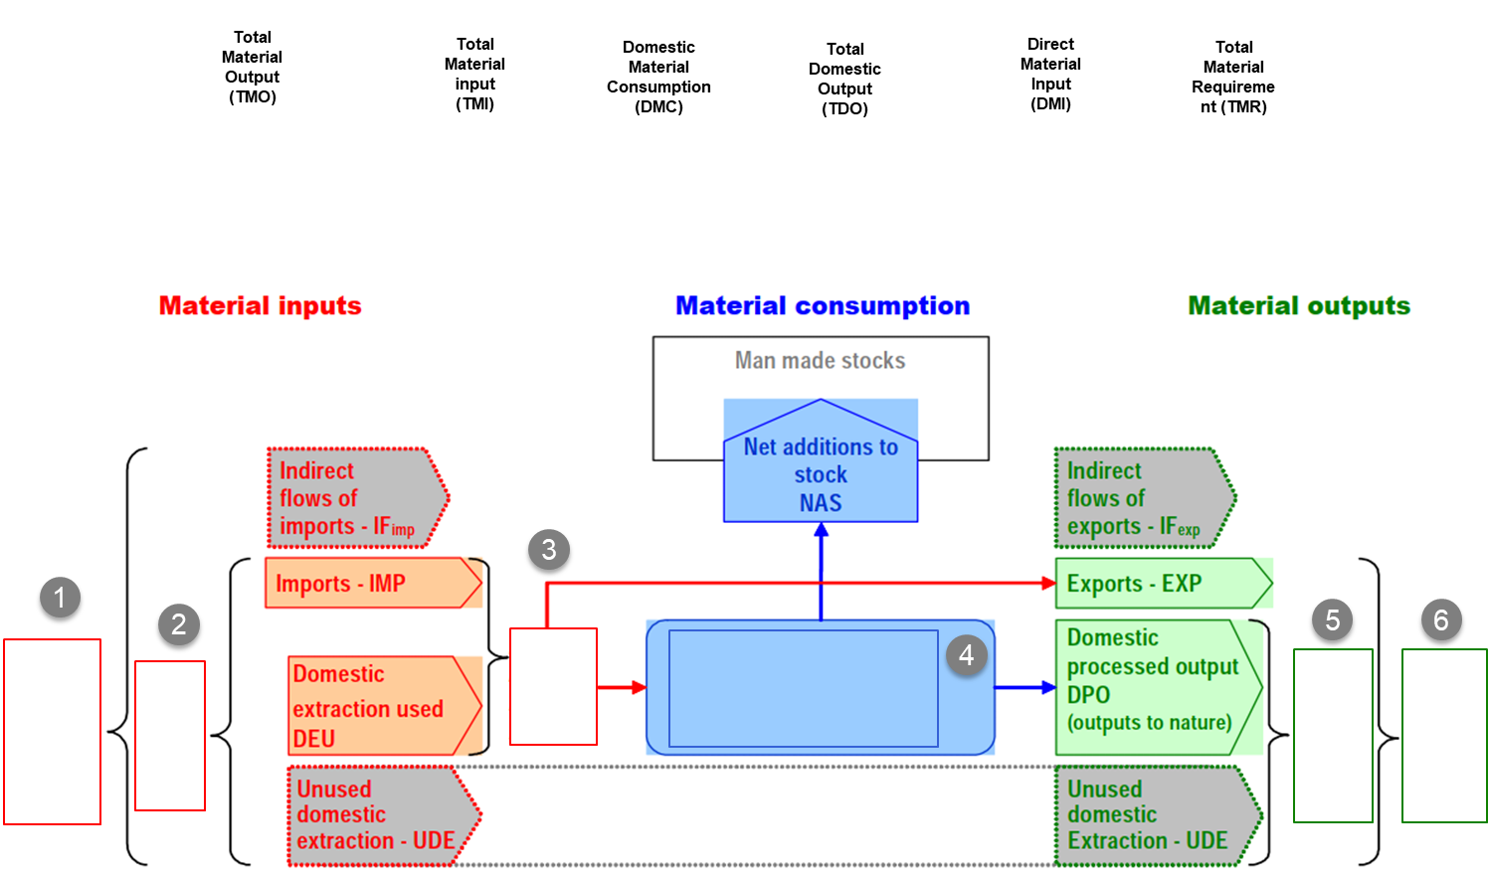
Figure 2: Exercise template for allocation of resource use indicators (adapted from: https://www.oecd.org/environment/indicators-modelling-outlooks/MFA-Guide.pdf)
Worksheet 2
Data Sources
Agricultural statistics  (cereals, vegetables etc. produced) | Environmental accounts for air emissions | Energy statistics and balances (extraction of fuels)
Energy statistics  (emission inventories) | Forestry statistics  (timber harvested) | Agricultural statistics for fertilizer use
 | Data Sources for Material Input:
 | Data Sources for Material Output:

